**Soft Skil Module-3**

**Task 1: Aptitude Test**

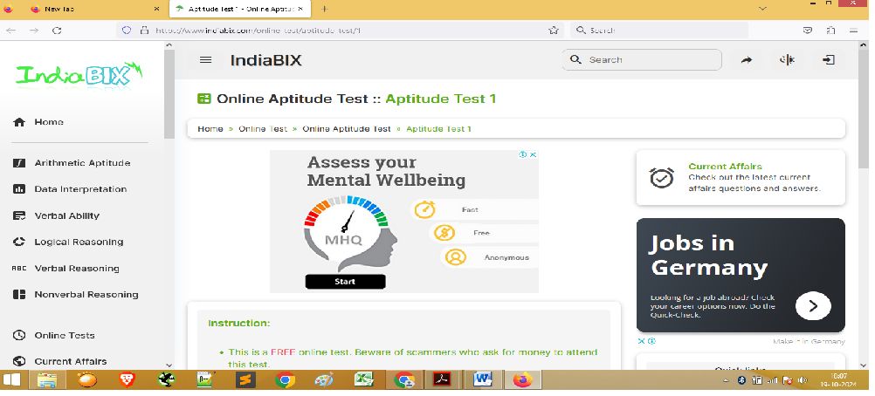

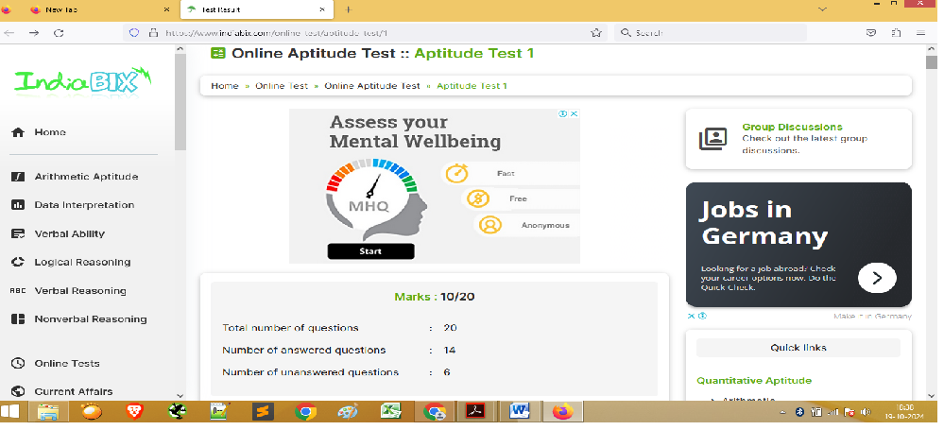

**Task 2: Presentation / Self Elevator pitch Video**

**Youtube Video Link-**

https://youtube.com/shorts/NH0NNU4VnuE?feature=share